The Cell Death Pathways
“To be, or not to be: that is the question.” While we all are poised at life-or-death decisions, this existential dichotomy is exceptionally stark for embryonic cells. Programmed cell death, called apoptosis,* is a normal part of development. In the nematode C. elegans, in which we can count the number of cells, exactly 131 cells die according to the normal developmental pattern. All the cells of this nematode are “programmed” to die unless they are actively told not to undergo apoptosis. In humans, as many as 10¹¹ cells die in each adult each day and are replaced by other cells. (Indeed, the mass of cells we lose each year through normal cell death is close to our entire body weight!) Within the uterus, we were constantly making and destroying cells, and we generated about three times as many neurons as we eventually ended up with when we were born. Lewis Thomas (1992) has aptly noted,
By the time I was born, more of me had died than survived. It was no wonder I cannot remember; during that time I went through brain after brain for nine months, finally contriving the one model that could be human, equipped for language.
Apoptosis is necessary not only for the proper spacing and orientation of neurons, but also for generating the middle ear space, the vaginal opening, and the spaces between our fingers and toes Saunders and Fallon 1966Roberts and Miller 1998;Rodriguez et al. 1997. Apoptosis prunes away unneeded structures, controls the number of cells in particular tissues, and sculpts complex organs.
Different tissues use different signals for apoptosis. One of the signals often used in vertebrates is bone morphogenetic protein 4 (BMP4). Some tissues, such as connective tissue, respond to BMP4 by differentiating into bone. Others, such as the frog gastrula ectoderm, respond to BMP4 by differentiating into skin. Still others, such as neural crest cells and tooth primordia, respond by degrading their DNA and dying. In the developing tooth, for instance, numerous growth and differentiation factors are secreted by the enamel knot. After the cusp has grown, the enamel knot synthesizes BMP4 and shuts itself down by apoptosis (see Chapter 13; Vaahtokari et al. 1996b).
In other tissues, the cells are “programmed” to die, and they will remain alive only if some growth or differentiation factor is present to “rescue” them. This happens during the development of mammalian red blood cells. The red blood cell precursors in the mouse liver need the hormone erythropoietin in order to survive. If they do not receive it, they undergo apoptosis. The erythropoietin receptor works through the JAK-STAT pathway, activating the Stat5 transcription factor. In this way, the amount of erythropoietin present can determine how many red blood cells enter the circulation.
One of the pathways for apoptosis was largely delineated through genetic studies of C. elegans. It was found that the proteins encoded by the ced-3 and ced-4 genes were essential for apoptosis, but that in the cells that did not undergo apoptosis, those genes were turned off by the product of the ced-9 gene (Figure 6.27A; Hengartner et al. 1992). The CED-4 protein is a protease activating factor that activates CED-3, a protease that initiates the destruction of the cell. Mutations that inactivate the CED-9 protein cause numerous cells that would normally survive to activate their ced-3 and ced-4 genes and die. This leads to the death of the entire embryo. Conversely, gain-of-function mutations of ced-9 cause CED-9 protein to be made in cells that would otherwise die. Thus, the ced-9 gene appears to be a binary switch that regulates the choice between life and death on the cellular level. It is possible that every cell in the nematode embryo is poised to die, and those cells that survive are rescued by the activation of the ced-9 gene.
The CED-3 and CED-4 proteins form the center of the apoptosis pathway that is common to all animals studied. The trigger for apoptosis can be a developmental cue such as a particular molecule (such as BMP4 or glucocorticoids) or the loss of adhesion to a matrix. Either type of cue can activate the CED-3 or CED-4 proteins or inactivate the CED-9 molecules. In mammals, the homologues of the CED-9 protein are members of the Bcl-2 family of genes. This family includes Bcl-2,Bcl-X, and similar genes. The functional similarities are so strong that if an active human BCL-2 gene is placed into C. elegans embryos, it prevents normally occurring cell deaths in the nematode embryos (Vaux et al. 1992). In vertebrate red blood cell development (mentioned above), the Stat5 transcription factor activated by erythropoietin functions by binding to the promoter of the Bcl-X gene, where it activates the synthesis of that anti-apoptosis protein (Socolovsky et al. 1999).
The mammalian homologue of CED-4 is called Apaf-1 (apoptotic protease activating factor-1), and it participates in the cytochrome c-dependent activation of the mammalian CED-3 homologues, the proteases caspase-9 and caspase-3 (Shaham and Horvitz 1996; Cecconi et al. 1998; Yoshida et al. 1998). The activation of the caspases causes the autodigestion of the cell. Caspases are strong proteases, and they digest the cell from within. The cellular proteins are cleaved and the DNA is fragmented.†
While apoptosis-deficient nematodes deficient for CED-4 are viable (despite their having 15% more cells than wild-type worms), mice with loss-of-function mutations for either caspase-3 or caspase-9 die around birth from massive cell overgrowth in the nervous system (Figure 6.28; Kuida et al. 1996, 1998; Jacobson et al. 1997). Mice homozygous for targeted deletions of Apaf-1 have severe craniofacial abnormalities, brain overgrowth, and webbing between their toes.
In mammals, there is more than one pathway to apoptosis. The apoptosis of the lymphocytes, for instance, is not affected by the deletion of Apaf-1 or caspase-9, and works by a separate pathway initiated by the CD95 protein (Figure 6.27B,C) Different caspases may be functioning in different cell types to mediate the apoptotic signals (Hakem et al. 1998; Kuida et al. 1998).
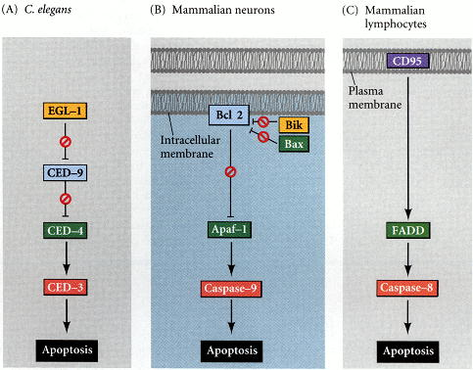
Figure 6.27. Apoptosis pathways in nematodes and mammals. (A) In C. elegans, the CED-4 protein is a protease activating factor that can activate the CED-3 protease. The CED-3 protease initiates the cell destruction events. CED-9 can inhibit CED-4 (and CED-9 can be inhibited upstream by EGL-1). (B) In mammals, a similar pathway exists, and appears to function in a similar manner. In this hypothetical scheme for the regulation of apoptosis in mammalian neurons, Bcl-x_{L}(a member of the Bcl-2 family) binds Apaf-1 and prevents it from activating the precursor of caspase-9. The signal for apoptosis allows another protein (here, Bik) to inhibit the binding of Apaf-1 to Bcl-x_{L}. Now, Apaf-1 is able to bind to the caspase-9 precursor and cleave it. Caspase-9 now dimerizes and activates caspase-3, which initiates apoptosis. (C) In addition, there are other pathways, such as the one initiated by the CD95 protein in the cell membranes of lymphocytes. The same colors are used to represent homologous proteins. (After Adams and Cory 1998.)

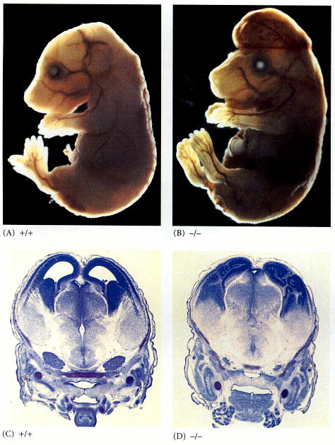
Figure 6.28. Disruption of normal brain development by blocking apoptosis. In mice in which caspase-9 or Apaf-1 has been knocked out, normal neural apoptosis fails to occur. In caspase 9-deficient mice, the overproliferation of brain neurons is obvious on a morphological level. (A) 16-day embryonic wild-type mouse. (B) Caspase 9-knockout mouse of the same age. The enlarged brain protrudes above the face, and the limbs are still webbed. This effect is confirmed by cross-sections through the forebrain at day 13.5 in (C) a normal mouse and (D) a caspase 9-knockout mouse. The knockout exhibits thickened ventricle walls and the near-obliteration of the ventricles. (From Kuida et al. 1998.)

